Certified Reliability Engineer — Online Workshop
18 September – 31 October 2026
REGISTRATION FORM
1. Participant Details
(Add a separate sheet if registering more than 3 participants — a 5% group discount applies for 2 or more participants from the same company/group.)
Sr. | Name | Designation | Mobile | Email
1
2
3

Company:
Address with pin code:
GST Number (if applicable):
2. Course Fees & Discounts
Candidates From | Fees per Participant | GST | Total | Currency
India | 32,119 | 5,781 | 37,900 | Indian Rupees
Other Countries | 590 | 0 | 590 | US Dollars
Early Registration Discounts
Discount | Registration Window | Total Payable (India) | Total Payable (International)
10% | Till 31 August 2026 | INR 34,110 | USD 531
5% | 1 – 6 September 2026 | INR 36,005 | USD 560
An additional 5% discount applies for 2 or more participants registering together from the same company or group.
3. What's Included
- Live online workshop as per schedule — about 80 hours
- Training material as per 2025 CRE BOK (PDF files sent online)
- Two online practice tests of 150 MCQs each
- Final 4-hour test of 150 MCQs, leading to certification from IQR as CRE for candidates meeting the passing criteria
- Access to recorded sessions for six months from the course start date
4. Payment Options
 | Bank QR Code  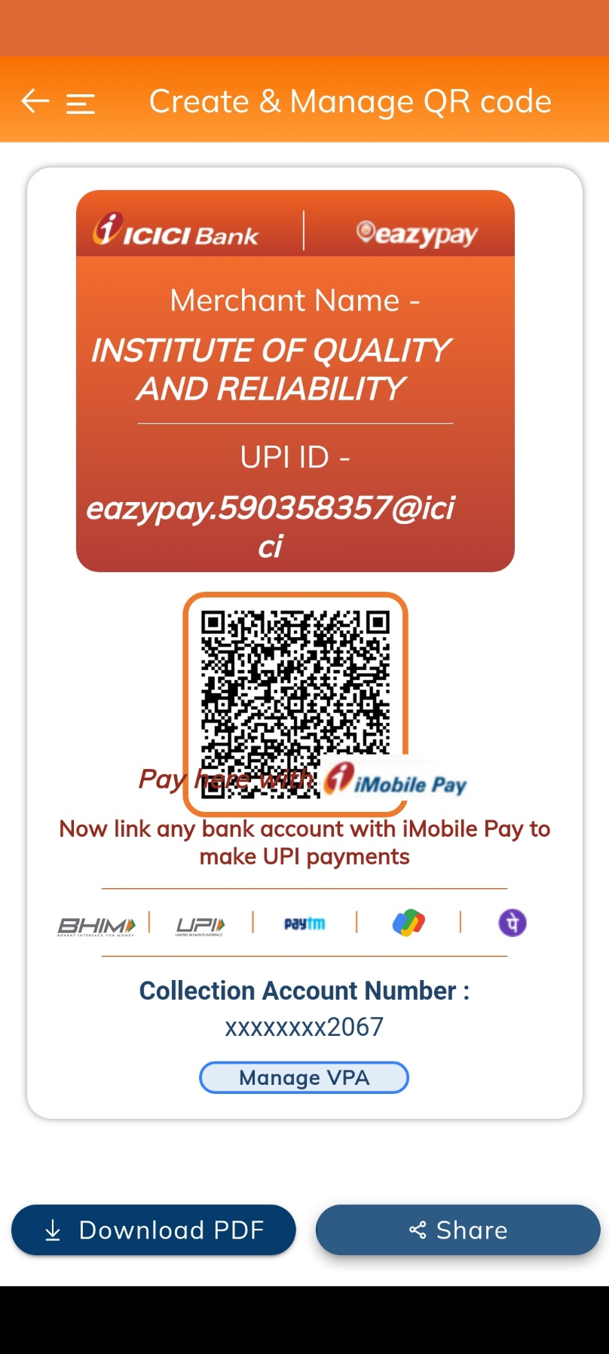
  Bank Transfer
  Account Name: Institute of Quality and Reliability
  Current Account No.: 003905502067
  Bank: ICICI Bank, Shivaji Nagar, Pune branch
  IFSC: ICIC0000039 Swift: ICICINBBCTS
  PAN: AABPU1469N GSTIN: 27ABPU1469N1Z4
  Razorpay (Alternate Option)
  Payments can also be made through Razorpay, in Indian Rupees or US Dollars. Write to us and we will send a payment link.
5. How to Register
Email this completed form to ioqr@world-class-quality.com along with payment details. Registration is confirmed on receipt of payment to “Institute of Quality and Reliability, Pune.”
Institute of Quality and Reliability
Plot No. 39, Shantiban Society, Near Gandhi Bhavan, Kothrud, Pune 411038, India
Hemant Urdhwareshe: +91 98220 14488 | Yashwant Mahakal: +91 99602 70692
Note: Please send an SMS or WhatsApp message if a call is not answered.
Email: ioqr@world-class-quality.com | Web: www.world-class-quality.com

